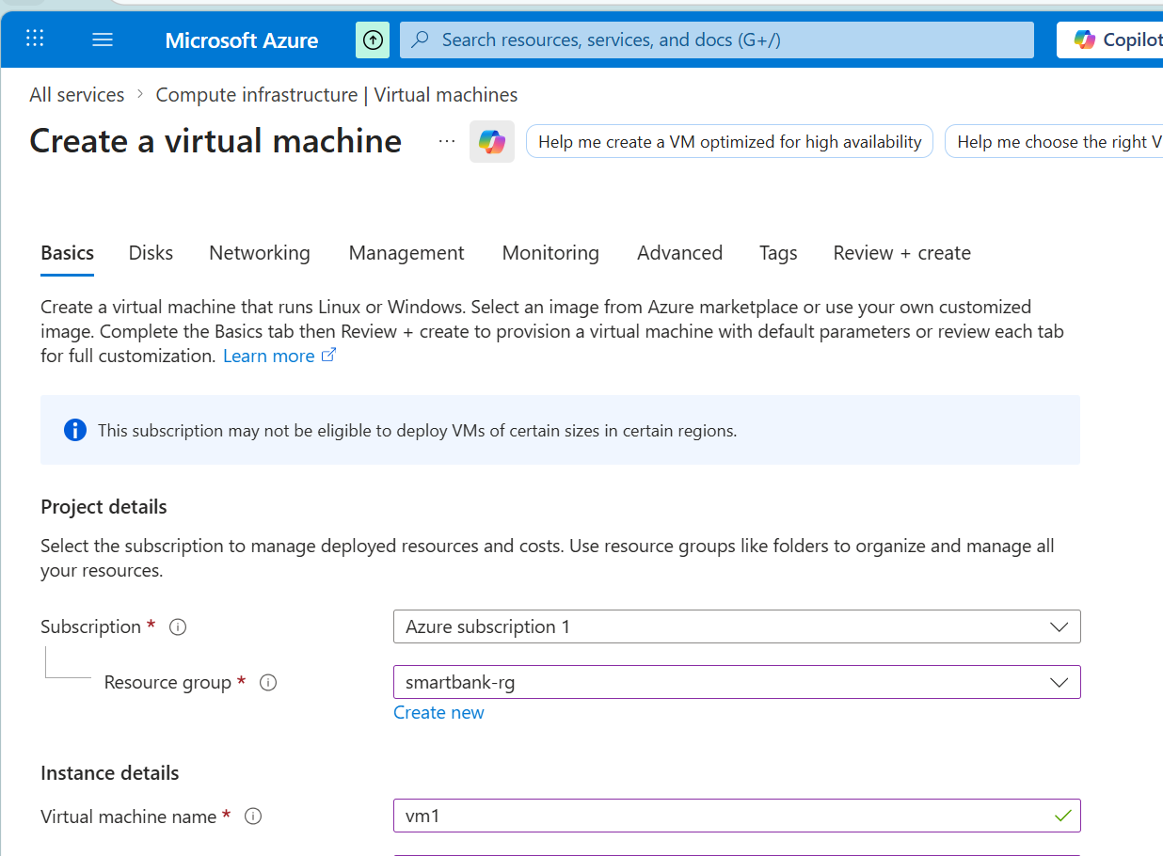

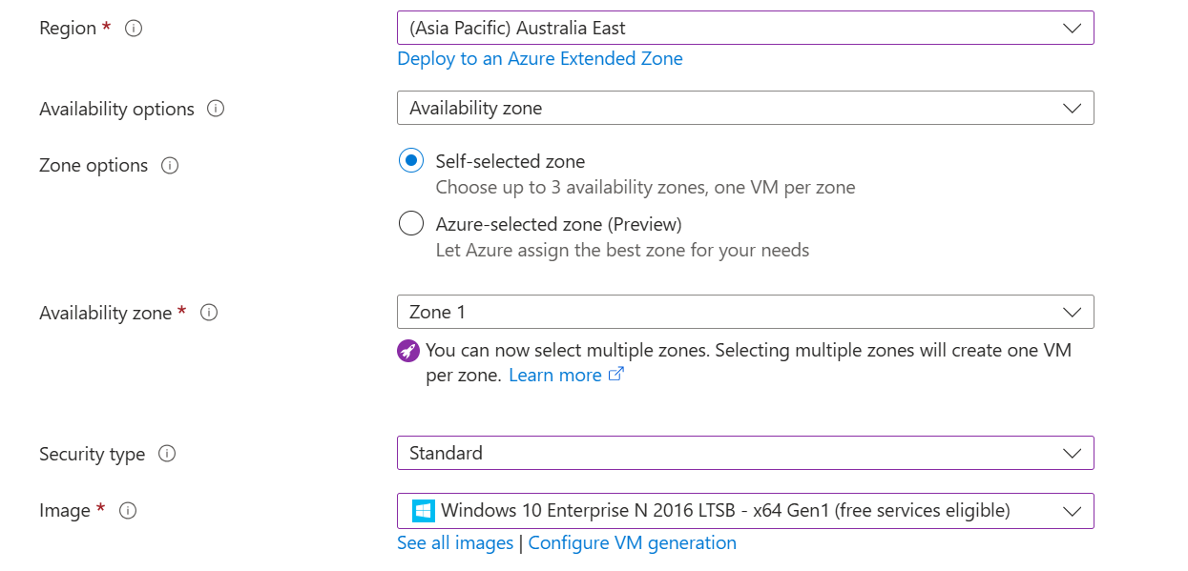

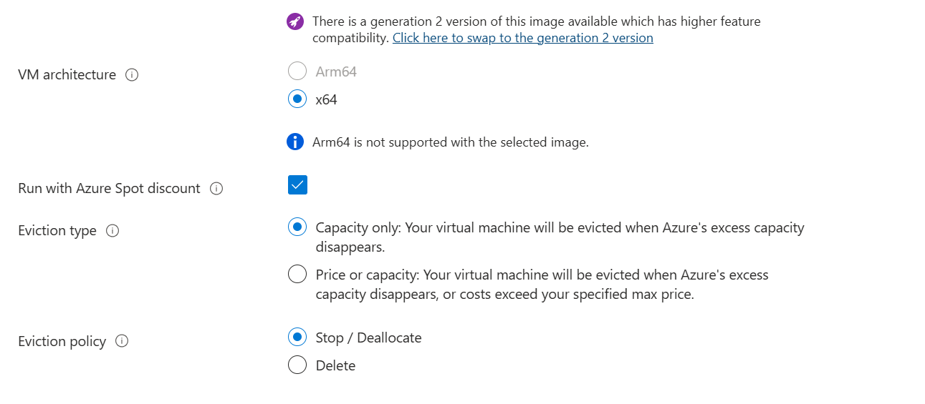

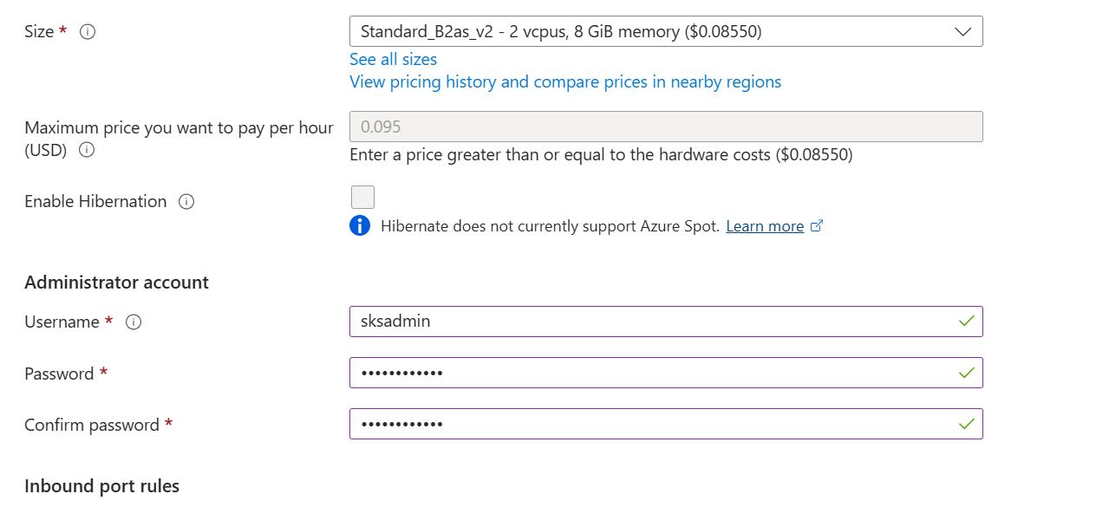

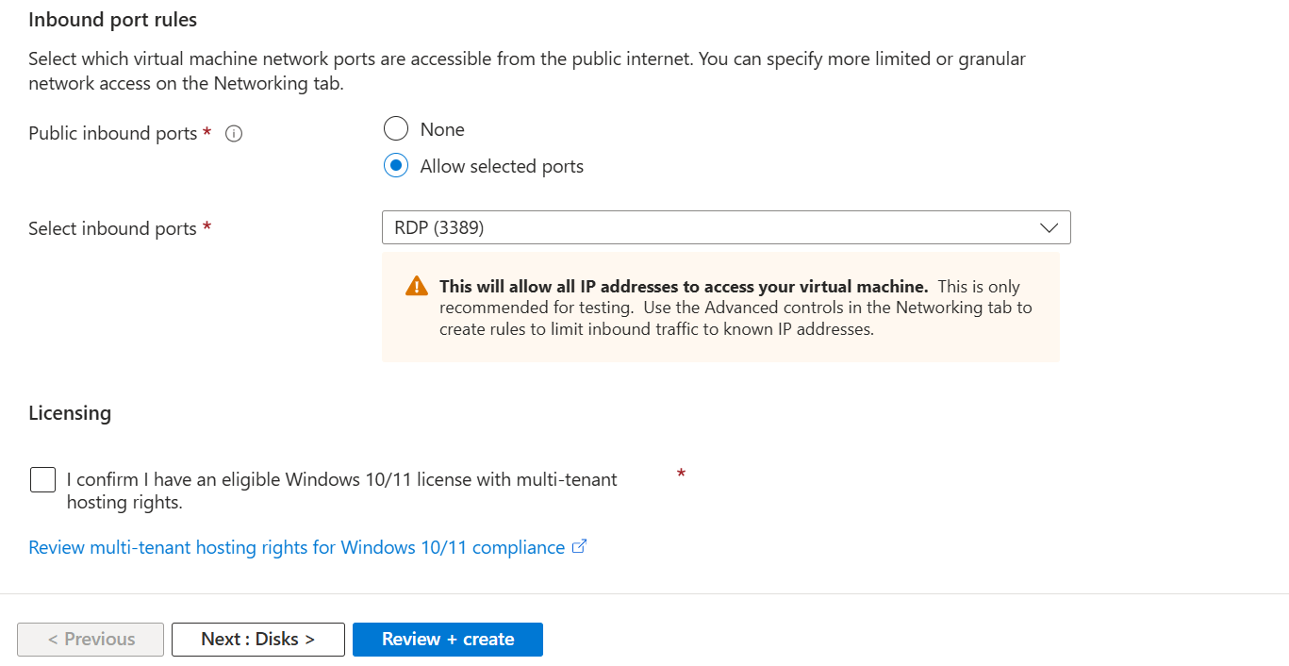

⚠️ Important Practical Notes
This is AUTO-INFRA creation mode
This single command automatically creates:
- VNet
- Subnet
- NSG (with RDP rule)
- Public IP
- NIC

# VARIABLES
$rg = "rg-test"
$location = "EastUS2"

$vmName = "vmtest"
$vnetName = "vnettest"
$subnetName = "subnet1"
$nsgName = "nsgtest"
$pipName = "piptest"

$vmSize = "Standard_DS1_v2"
$image = "Win2019Datacenter"

$username = "azureuser"
$password = "Azure@123456"

# CREDENTIAL OBJECT
$securePassword = ConvertTo-SecureString $password -AsPlainText -Force
$cred = New-Object System.Management.Automation.PSCredential ($username, $securePassword)

# CREATE RESOURCE GROUP (if not exists)
New-AzResourceGroup -Name $rg -Location $location -ErrorAction SilentlyContinue

# CREATE VM (Auto-creates VNet, Subnet, NSG, PIP)
New-AzVM `
-ResourceGroupName $rg `
-Location $location `
-Name $vmName `
-VirtualNetworkName $vnetName `
-SubnetName $subnetName `
-SecurityGroupName $nsgName `
-PublicIpAddressName $pipName `
-OpenPorts 3389 `
-Image $image `
-Size $vmSize `
-Credential $cred

